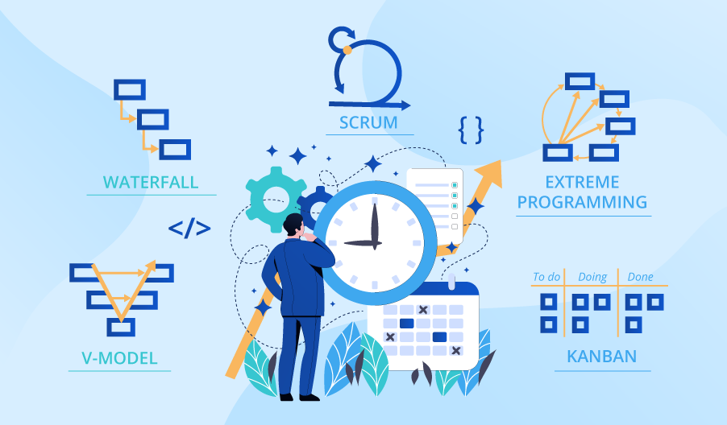

**SE423**

**Software Project Management**

**Activity**

**Activity 4. Risk Management Activity**

Working in groups of 3-4, complete the following activity.

Your software company has been hired to implement a nationwide on-line government budget dashboard before the next presidential election. What would the project risk section of your software project plan look like? Create a chart in Excel to identify the top ten risks based on risk exposure. Use the categories below as your column headers. Make sure to account for risks in all the major categories. For each risk identify:

1. ID
2. Description of Risk
3. Type of Risk (use McConnell's categories listed in chapter 5 of Rapid Development.)
4. Probability of occurrence of the risk, expressed as a number between 0.1 (highly unlikely) and 1.0 (guaranteed to happen). Alternately, you could rate this as low, medium, or high.
5. Impact Loss or Cost
6. Risk Exposure
7. First Indicator
8. Mitigation approach (two per risk)

Be sure to include all group member's names in your submission.